ABOUT PROJECT:

This project is an approach towards introducing technology in various fields to work faster, accurately and reliably. AIRLINE MANAGEMENT SYSTEM is an easy approach to Airlines Management. This software is capable of handling a huge customer’s data. Many inbuilt functions are added in this software which automatically works and process customer’s data such as reservations of tickets, verifications of tickets and cancellation of tickets. It automatically asks for the needed information sequentially. This project is very user friendly and also use powerful security features such as password protection to provide the security, so that only authorised users can access the information.

ABOUT PROJECT DEVELOPMENT:

The project AIRLINES MANAGEMENT SYSTEM is totally developed in C++ language (one of the most powerful programming language). Various concepts of C++ are used in the development such as Data Processing, Binary Search, Structures and Functions (inbuilt and user-defined). Some Functions are developed for automatically generate the Ticket Code which is never previously generated. All the data is stored in the files in binary mode. Special checks are used to provide a better error rectification. Moreover the errors in the file system and the customer’s data are automatically detected by the software. Moreover the project can be easily modified.

ABOUT PROJECT LIMITATONS:

In spite of all the above qualities the concept of Inheritance is not used here. But the further use of Inheritance in form of artificial intelligence in the programming can results in a big approach towards the Airline Management, which provides a better interaction to the users. The Encryption Mechanism, multiuser support, Database connectivity and Random Search Operations are not used. Also the GUI (Graphical User Interface) is not used.

PROJECT REQUIREMENTS:

* HARDWARE REQUIREMENTS:

1. **Processor:** 845 Intel Processor
2. **Main Memory**: 128 MB RAM
3. **HDD:** 20 GB
4. SVGA Color monitor
5. Logitech mouse
6. **105 keys keyboard**

* SOFTWARE REQUIREMENTS:

1. **Operating System:** WINDOWS 98 SE OR ABOVE.
2. **Programming Language:** TURBOC++
3. **Documentation:** MS-WORD 2000 OR HIGHER.
4. **Backup media:** Hard Disk Backup

**OUTPUT SCREENS:**

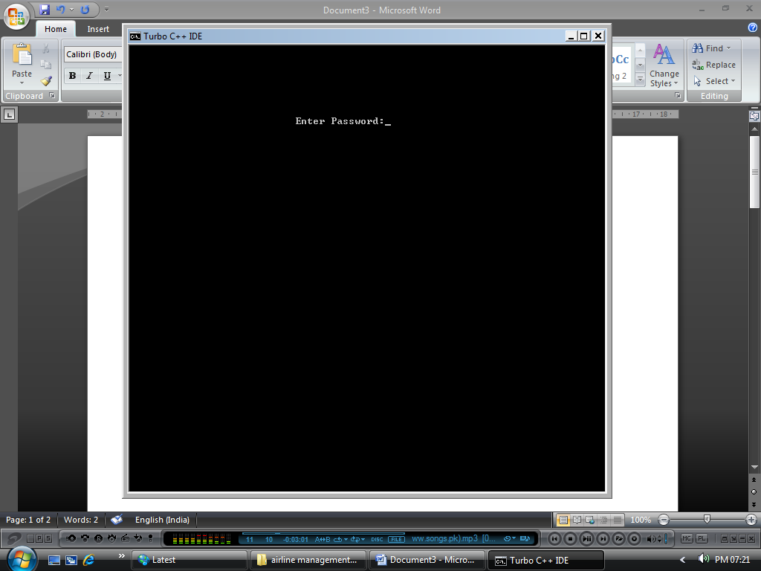

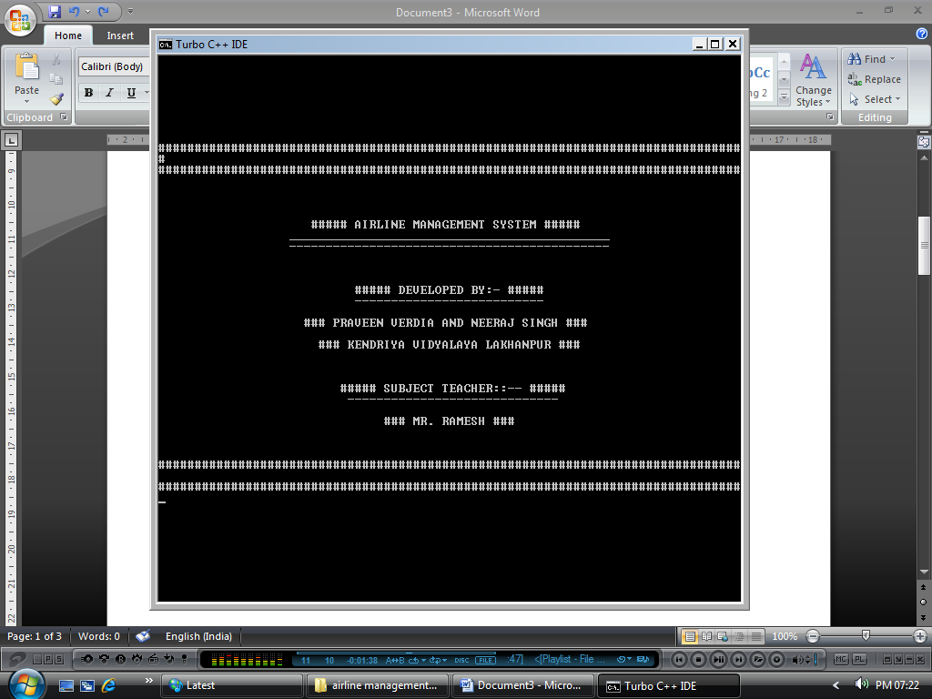

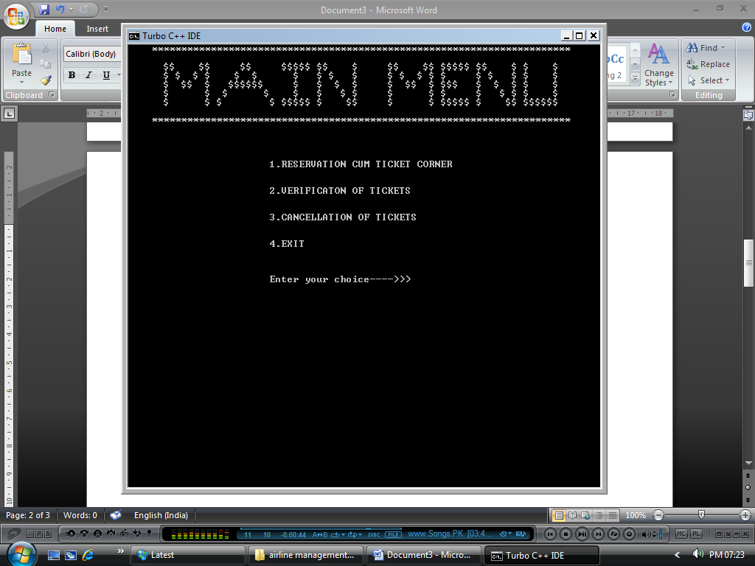

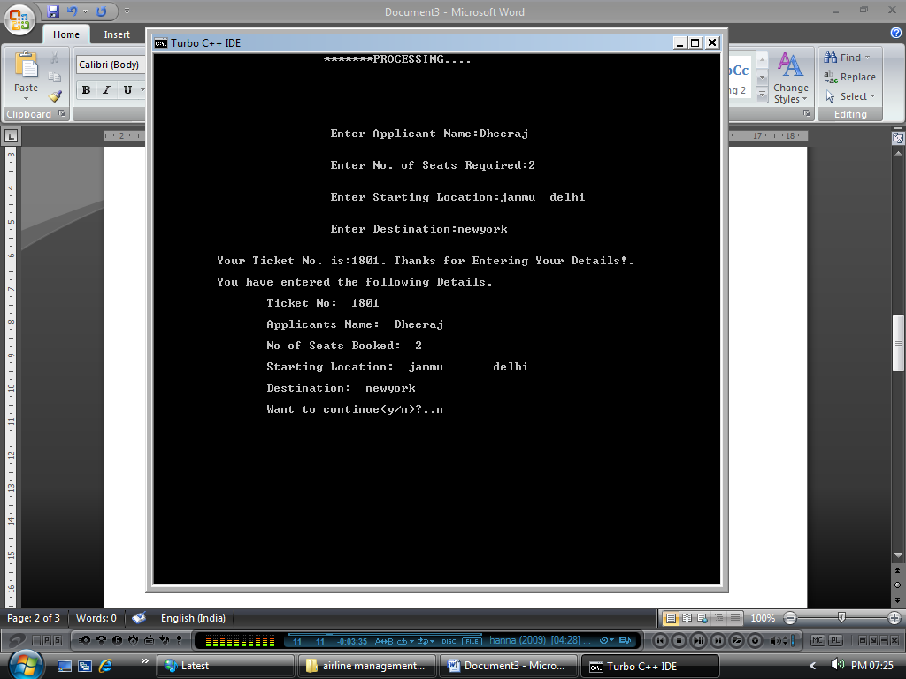

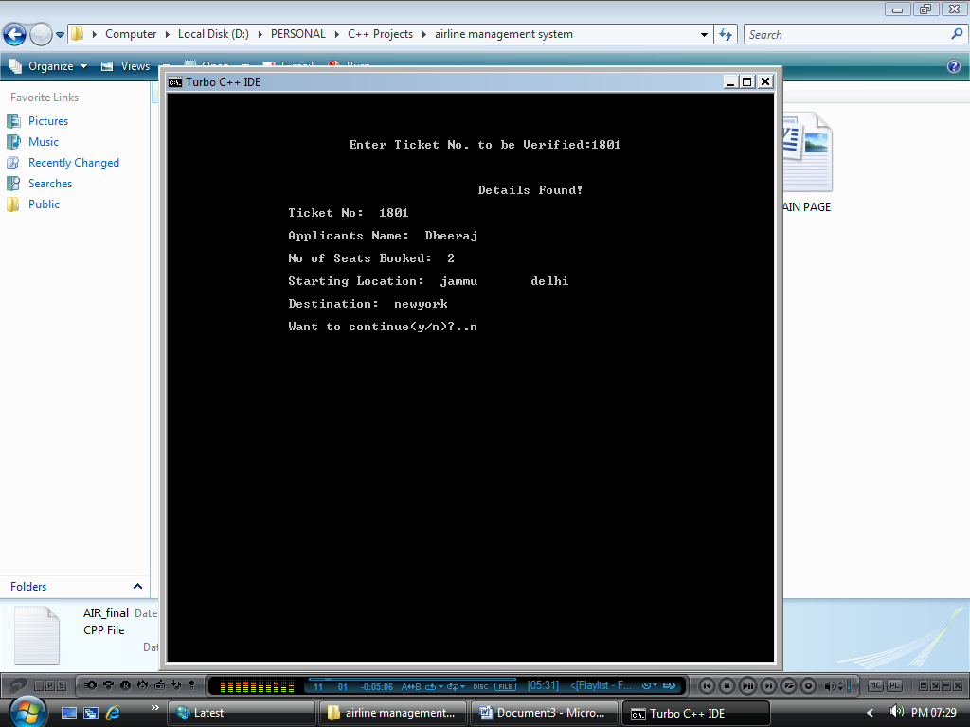

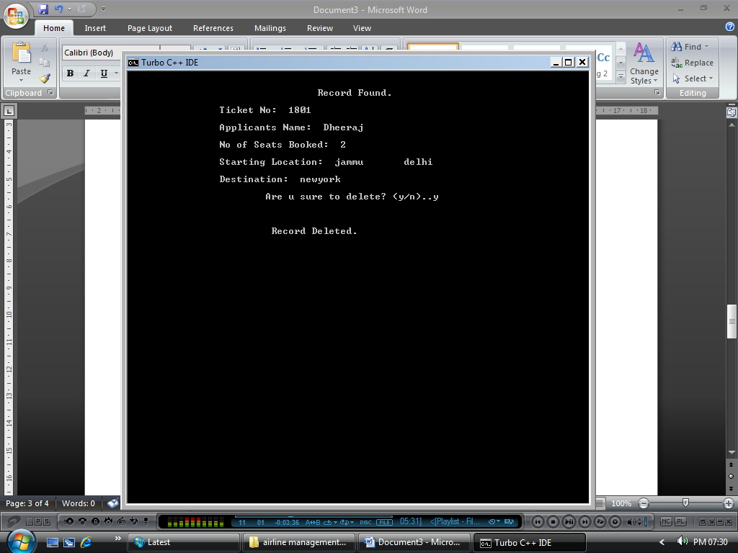

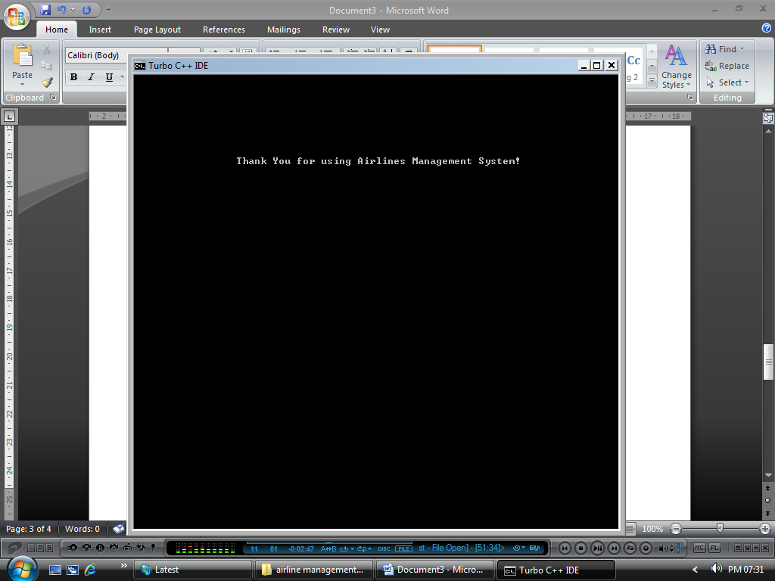

// Airline Management System.

PROGRAMME CODE:

#include<iostream.h>

#include<conio.h>

#include<dos.h>

#include<stdio.h>

#include<fstream.h>

#include<process.h>

#include<string.h>

// Structure to Store Customer data.

struct data

{private: char name[20];

char start[20];

char dest[20];

int seats;

int code;

public: void getinfo();

void showinfo();

int a;

int generator()

{ a=a+1;

code=a;

return code;

}

int tcode()

{

return code;

}

}d;

// Function to take customer data.

void data::getinfo()

{ cout<<"\n\n\n\n\t\t\t Enter Applicant Name:";

gets(name);

cout<<"\n\n\t\t\t Enter No. of Seats Required:";

cin>>seats;

cout<<"\n\n\t\t\t Enter Starting Location:";

gets(start);

cout<<"\n\n\t\t\t Enter Destination:";

gets(dest);

generator();

cout<<"\n\n\t Your Ticket No. is:"<<tcode()<<". Thanks for Entering Your Details!.";

getch();

}

// Function to display customer data.

void data::showinfo()

{

cout<<"\n\n\t\tTicket No:"<<" "<<code;

cout<<"\n\n\t\tApplicants Name:"<<" "<<name;

cout<<"\n\n\t\tNo of Seats Booked:"<<" "<<seats;

cout<<"\n\n\t\tStarting Location:"<<" "<<start;

cout<<"\n\n\t\tDestination:"<<" "<<dest;

getch();

}

// Function to store customer data.

void reservation()

{ ofstream f;

f.open("d.dat",ios::out|ios::app|ios::binary);

d.getinfo();

cout<<"\n\n\t You have entered the following Details.";

d.showinfo();

f.write((char*)&d,sizeof(d));

f.close();

}

// Function to Verify customer data.

void verification()

{ clrscr();

ifstream f3;

int flag=0;

int vcode;

cout<<"\n\n\n\n\t\t\tEnter Ticket No. to be Verified:";

cin>> vcode;

f3.open("d.dat",ios::in|ios::binary);

if(!f3)

cout<<"\n\n\n\t\t\t ERROR!!.. File doesn't exists.";

while(f3.read((char*)&d, sizeof(d)))

{

if(d.tcode()==vcode)

{ cout<<"\n\n\n\t\t\t\t\t Details Found!";

d.showinfo();

flag=1;

}

}

if(flag==0)

{

cout<<"\n\n\t\t\t Sorry! Record doesn't exist.";

getch();

}

f3.close();

}

// Function to delete customers data.

void cancellation(int vcode)

{ clrscr();

char found='f',confirm='n';

ifstream f1("d.dat",ios::in|ios::binary);

ofstream f2("t.dat",ios::out|ios::app|ios::binary);

while(f1.read((char*)&d,sizeof(d)))

{

if(d.tcode()==vcode)

{

cout<<"\n\n\t\t\t\t Record Found.";

d.showinfo();

found='t';

cout<<"\n\n\t\t\tAre u sure to delete? (y/n)..";

cin>>confirm;

if ((confirm=='y'||confirm=='Y'))

{

cout<<"\n\n\n\t\t\t Record Deleted.";

}

else

{

f2.write((char*)&d,sizeof(d));

cout<<"\n\n\t\t\tDelete operation Aborted by user.";

}

}

else

{

f2.write((char*)&d,sizeof(d));

}

}

if(found=='f')

cout<<"\n\n\t Sorry! Record not found. Please check your Ticket Code and Try again.";

getch();

f1.close();

f2.close();

remove("d.dat");

rename("t.dat","d.dat");

}

// Main Function.

void main()

{ d.a=1800;

clrscr();

char ip[8];

int atm=0;

pcheck: if(atm<3)

{

clrscr();

cout<<"\n\n\n\n\n\n\n\n\t\t\t Enter Password:";

gets(ip);

if((strcmp(ip,"password"))==0)

goto start;

else

{

cout<<"\n\n\t\t You have entered wrong Password. Please try Again.";

getch(); atm++;

goto pcheck;

}}

else

{

cout<<"\n\n\n\n\t You have entered wrong password for consecutive three times.\n\n\t\t Now the program is terminated. Thank You!";

getch();

exit(0);

}

start: clrscr();

cout<<"\n\n\n\n\n\n\n\n";

cout<<"#################################################################################";

cout<<"\n################################################################################";

cout<<"\n\n\n\n";

cout<<"\t\t ##### AIRLINE MANAGEMENT SYSTEM #####";

cout<<"\n\t\t ____________________________________________";

cout<<"\n\t\t --------------------------------------------";

cout<<"\n\n\n\n";

cout<<"\t\t ##### DEVELOPED BY:- #####";

cout<<"\n\t\t\t --------------------------";

cout<<"\n\n\t\t ### PRAVEEN VERDIA AND NEERAJ SINGH ###";

cout<<"\n\n\t\t ### KENDRIYA VIDYALAYA LAKHANPUR ###";

cout<<"\n\n\n\n";

cout<<"\t\t\t ##### SUBJECT TEACHER::-- #####";

cout<<"\n\t\t\t -----------------------------";

cout<<"\n\n\t\t\t ### MR. RAMESH ###";

cout<<"\n\n\n\n################################################################################";

cout<<"\n################################################################################";

getch();

clrscr();

cout<<"\n\n\n\n:";

label:

clrscr();

cout<<" ***********************************************************************\n\

cout<<" $$ $$ $$ $$$$$ $$ $ $$ $$ $$$$$ $$ $ $ $\n";

cout<<" $ $ $ $ $ $ $ $ $ $ $ $ $ $ $ $ $ $ $ $\n";

cout<<" $ $$ $ $$$$$$ $ $ $ $ $ $$ $ $$$ $ $ $ $ $\n";

cout<<" $ $ $ $ $ $ $ $ $ $ $ $ $ $ $ $\n";

cout<<" $ $ $ $ $$$$$ $ $$ $ $ $$$$$ $ $$ $$$$$$\n\n";

cout<<" ***********************************************************************\n\n";

int choice;

char d;

cout<<"\n\n\n\t\t\t1.RESERVATION CUM TICKET CORNER";

cout<<"\n\n\n\t\t\t2.VERIFICATON OF TICKETS";

cout<<"\n\n\n\t\t\t3.CANCELLATION OF TICKETS";

cout<<"\n\n\n\t\t\t4.EXIT\n\n";

delay(500);

cout<<"\n\n\t\t\tEnter your choice---->>>";

cin>>choice;

switch(choice)

{

case 1: clrscr();

cout<<"\t\t\t*******PROCESSING.";delay(500);cout<<".";delay(500);

cout<<".";delay(500);cout<<".\n\n\n";

do

{

reservation();

cout<<"\n\n\t\tWant to continue(y/n)?..";

cin>>d;

clrscr();

}while(d=='y'||d=='Y');

goto label;

case 2: clrscr();

cout<<"\t\t\t*******PROCESSING.";delay(500);cout<<".";delay(500);

cout<<".";delay(500);cout<<".\n\n\n";

do

{

verification();

cout<<"\n\n\t\tWant to continue(y/n)?..";

cin>>d;

}while(d=='y'||d=='Y');

goto label;

case 3: clrscr();

cout<<"\t\t\t*******PROCESSING.";delay(500);cout<<".";delay(500);

cout<<".";delay(500);cout<<".\n\n\n";

int c_ticket;

do

{

cout<<"\n\n\tEnter Ticket No. to be Cancelled:";

cin>>c_ticket;

cancellation(c_ticket);

cout<<"\n\n\t\tWant to continue(y/n)?..";

cin>>d;

}while(d=='y'||d=='Y');

goto label;

case 4: clrscr();

cout<<"\n\n\n\n\n\n\n\n\n\t\t Thank You for using Airlines Management System!";

getch();

exit(0);

break;

default: cout<<"\n\t\tYou have entered wrong choice!!!!!.. Please Try Again.";

getch();

goto label;

}

getch();

}

// Main Function Ends Here.

// Programme ends here.